Notes for Reverse Chucking:

- Do not remove the turning from the original mount: faceplate, chucked, screw chuck, other. You may think you can remount it as it was, but you really can’t !

- Use an adapter into your tailstock (Morse taper to thread) and remount original mount device into the tailstock. These adapters are not overly expensive (~$29). They are extremely useful and necessary.
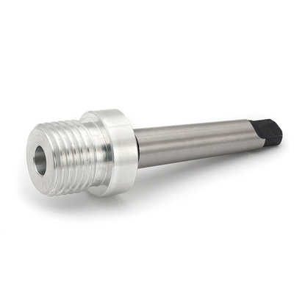
- Mount the new mount method onto the headstock threads. Bring tailstock towards headstock for the new mount: Longworth, Coles, Vacuum, entrapment, etc.

- Secure the mounting method to the piece with use of the tailstock position as needed to get a clean and tight mount. If using a vacuum mount, make sure that it holds sufficient vacuum to keep the piece in place. Each size vacuum fixture will determine how much vacuum is needed. If end grain turning, try to use the minimum vacuum possible to securely hold the piece in place.

- Finally, release the tailstock mount method and back off the tailstock.

You are now ready to finish the underside/bottom of the project.

- Bring tailstock into piece with live center if you need more security to the initial cuts of the bottom/back of the piece.

- Turn satisfactory amounts to finish state toward the tailstock live center

- Remove the tailstock/live center and final turn the nub or middle of the prior surface as needed.

- Sand and polish as desired.

You can now remove the mount from the headstock and take the piece off any mounting in place (i.e. Coles, Longworth, trapped, etc.).

